1. Navigate to <https://trials.dynamics.com/>
2. Click the **sign up here** link that’s highlighted in the screen shot below

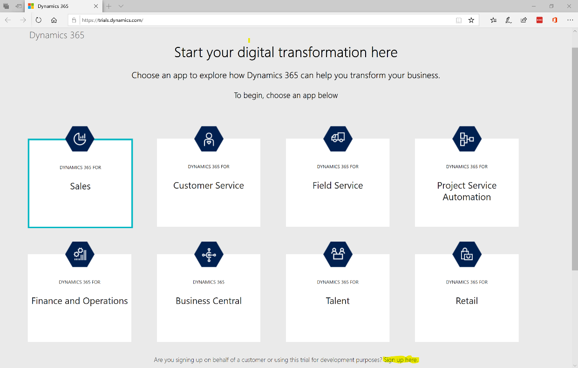

1. Click **no continue signing up** in the dialog that pops up as highlighted in the screen shot below

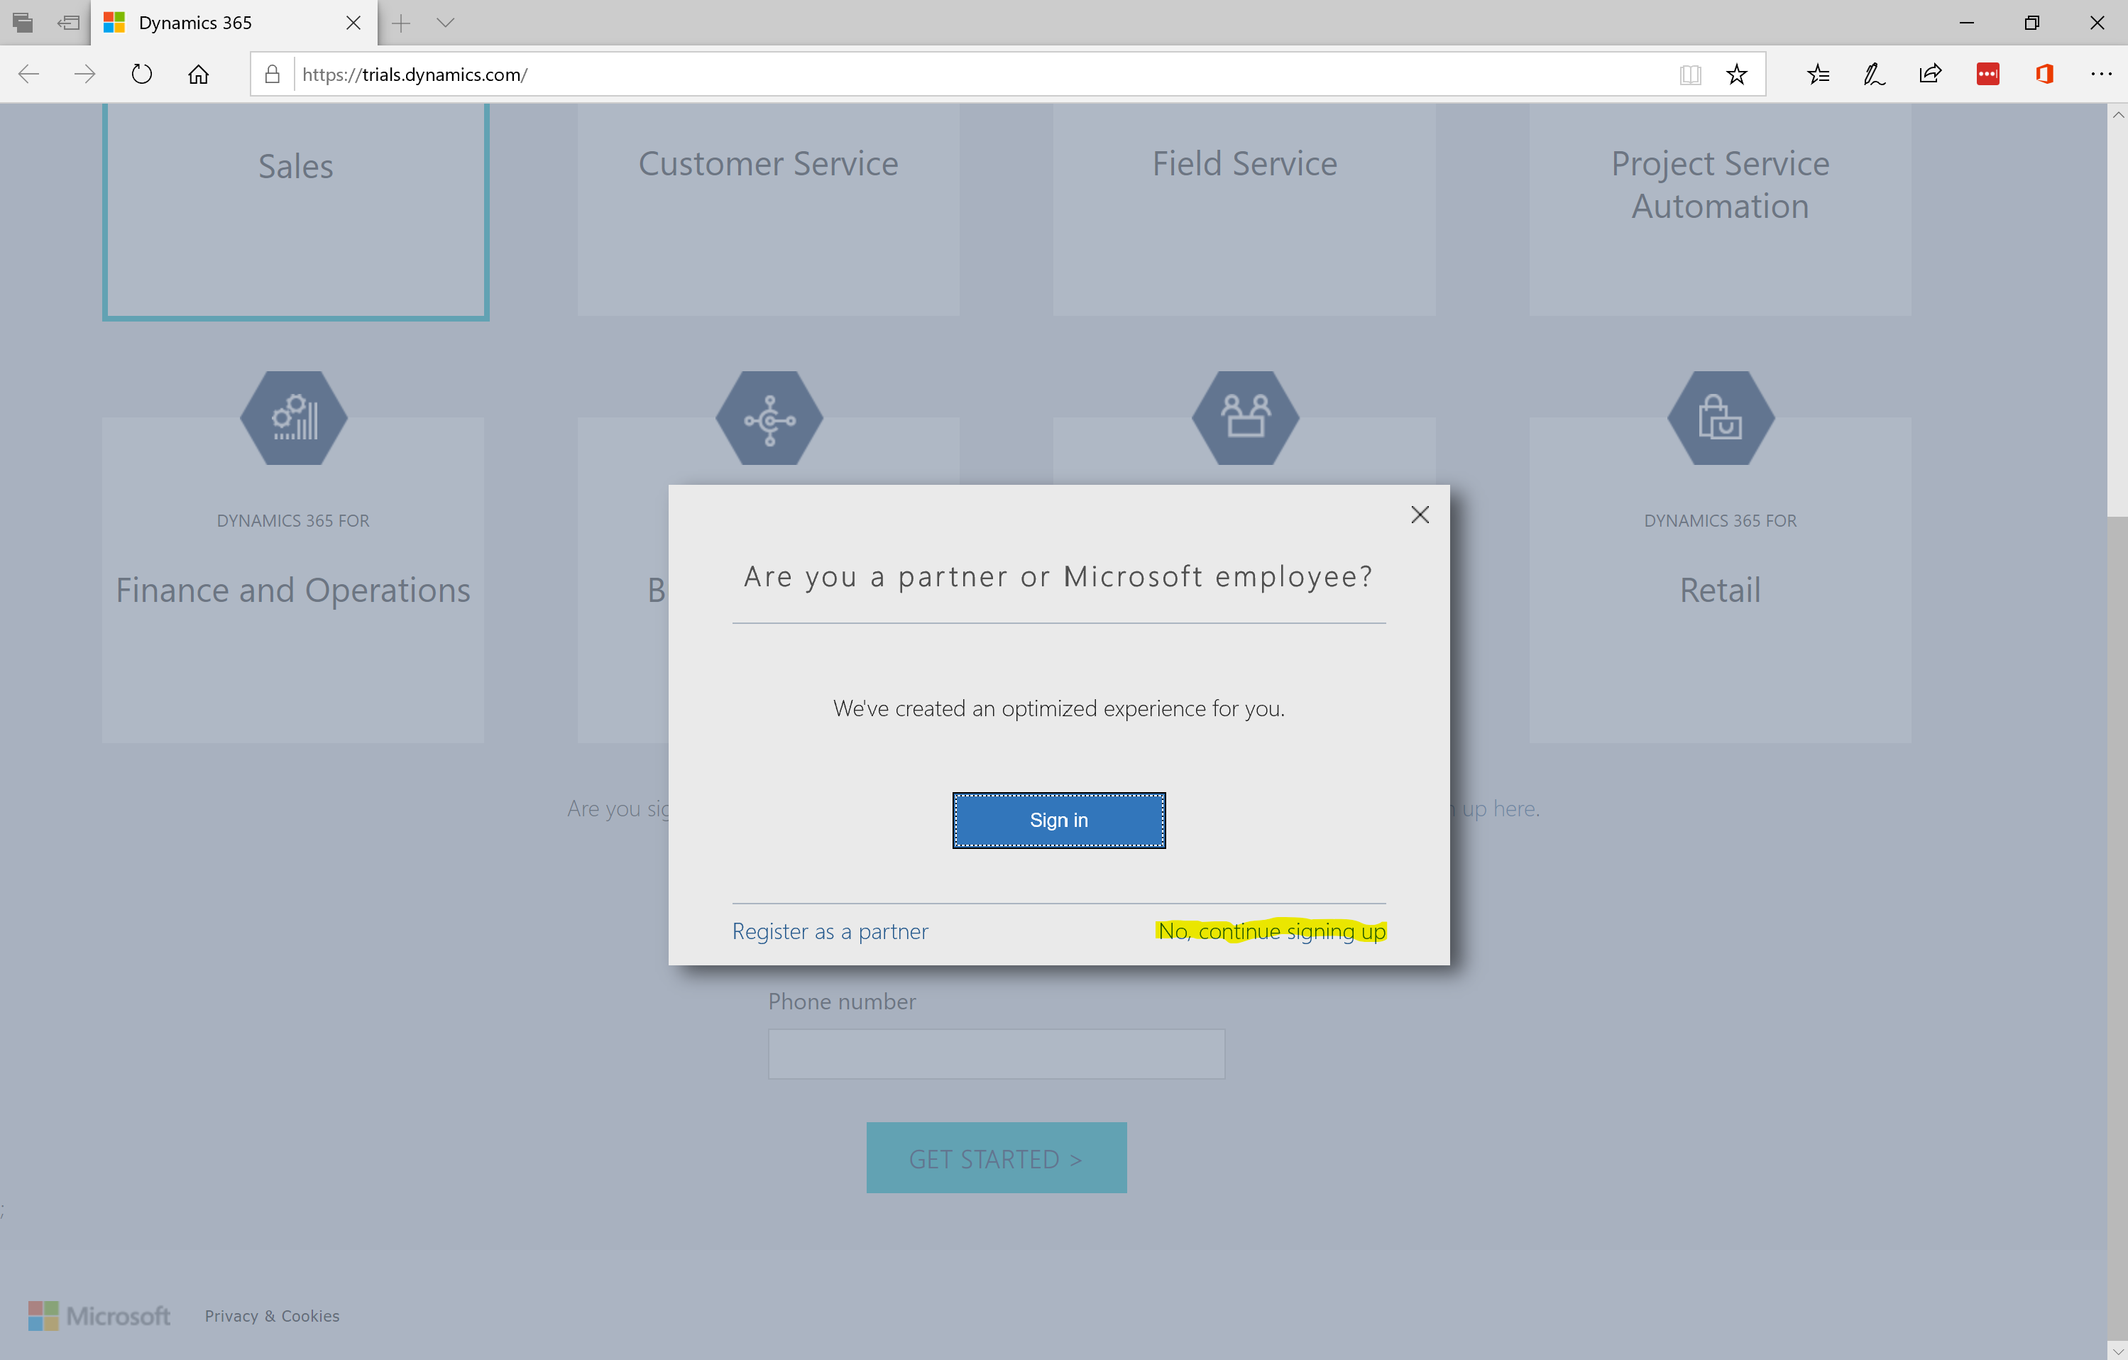

1. Fill out the information as requested in the screen shot below using a personal email address (e.g., gmail, outlook, MSN, yahoo, etc…) and click **next**. Do not click “want to add this to an existing subscription.

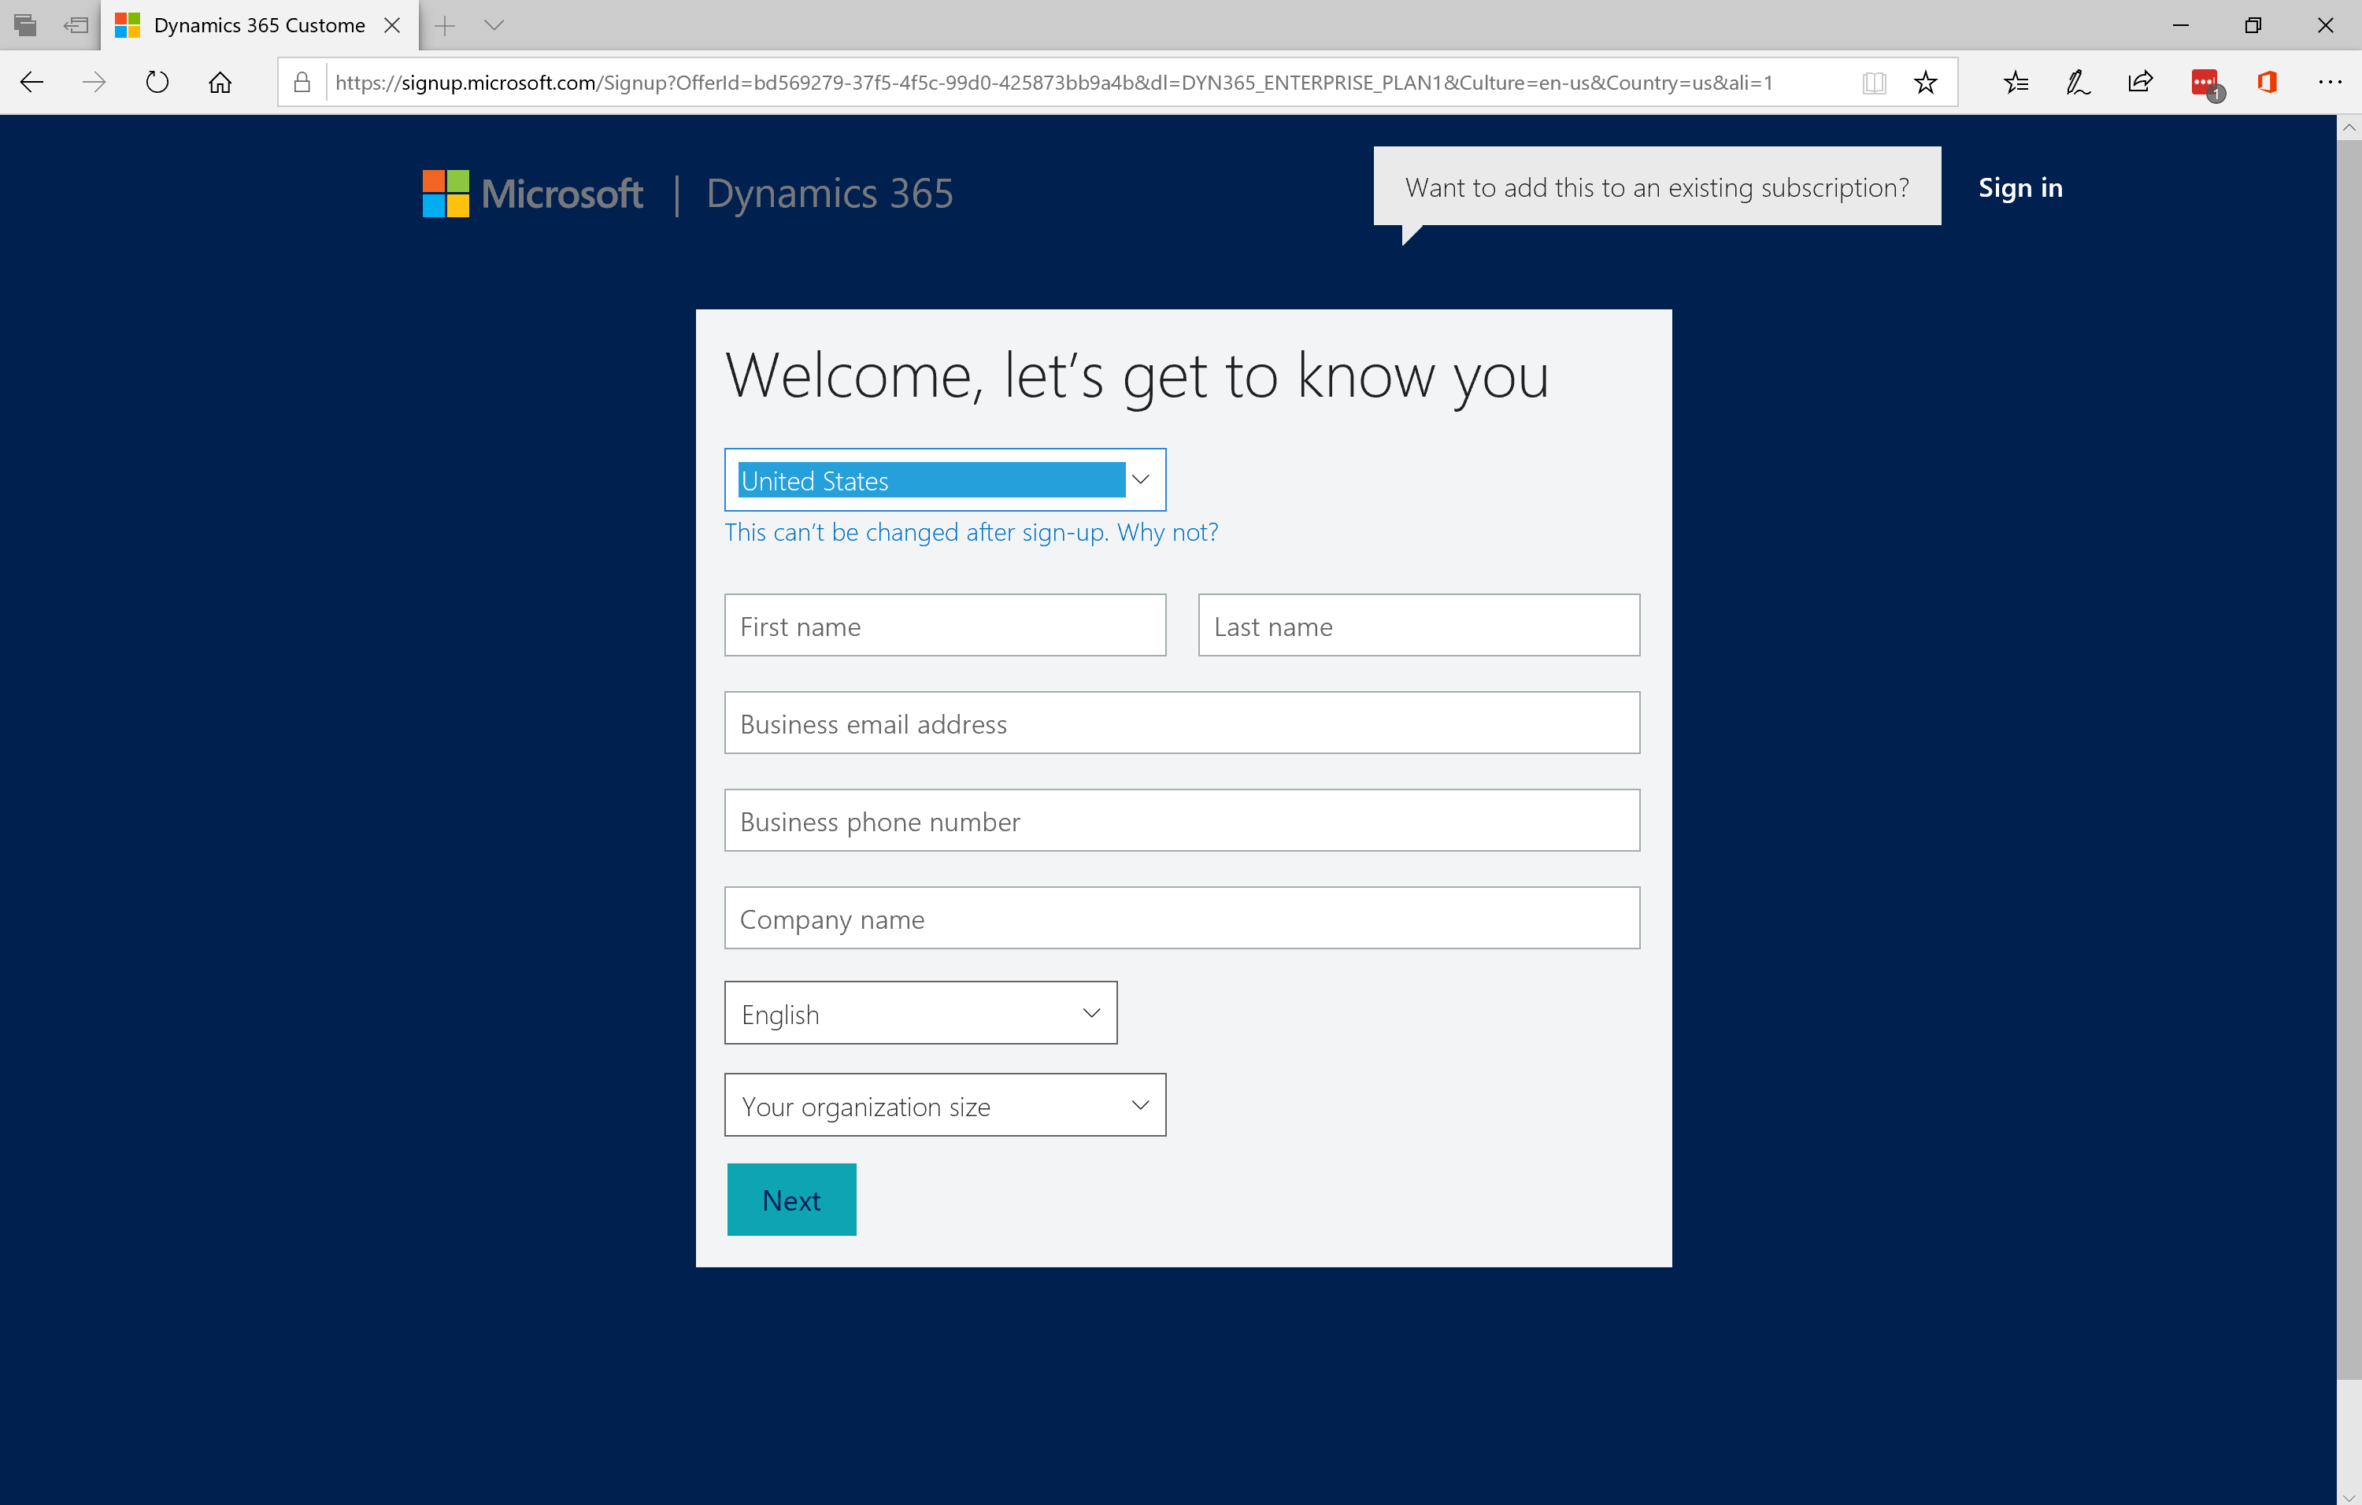

1. Fill out the information as requested in the screen shot below with a user name and company name of your choosing and click **create my account**. Do not click “want to add this to an existing subscription.

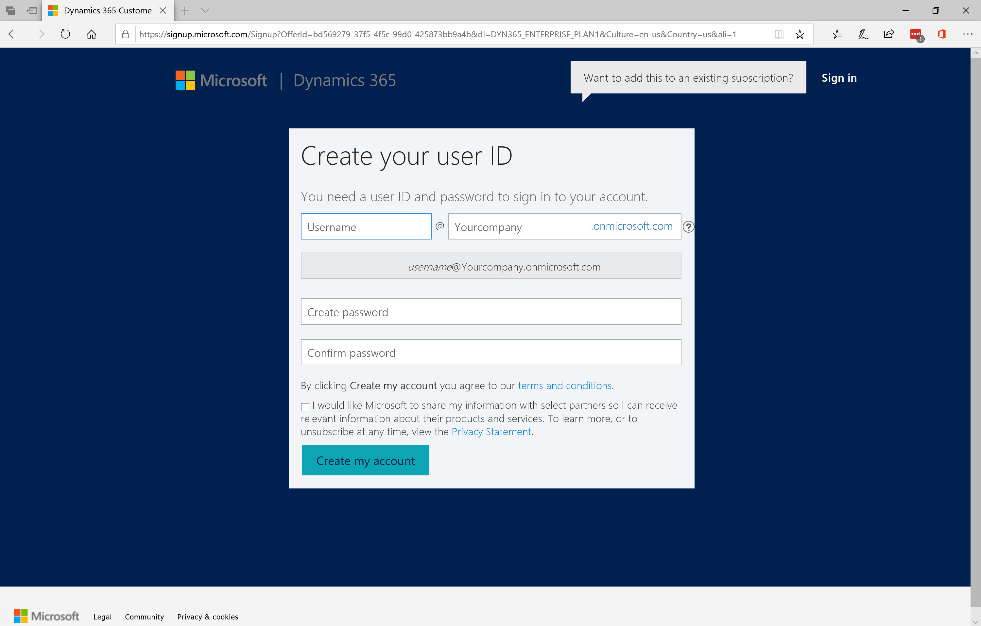

1. Follow the instructions to prove you’re not a robot and then you’re almost there!

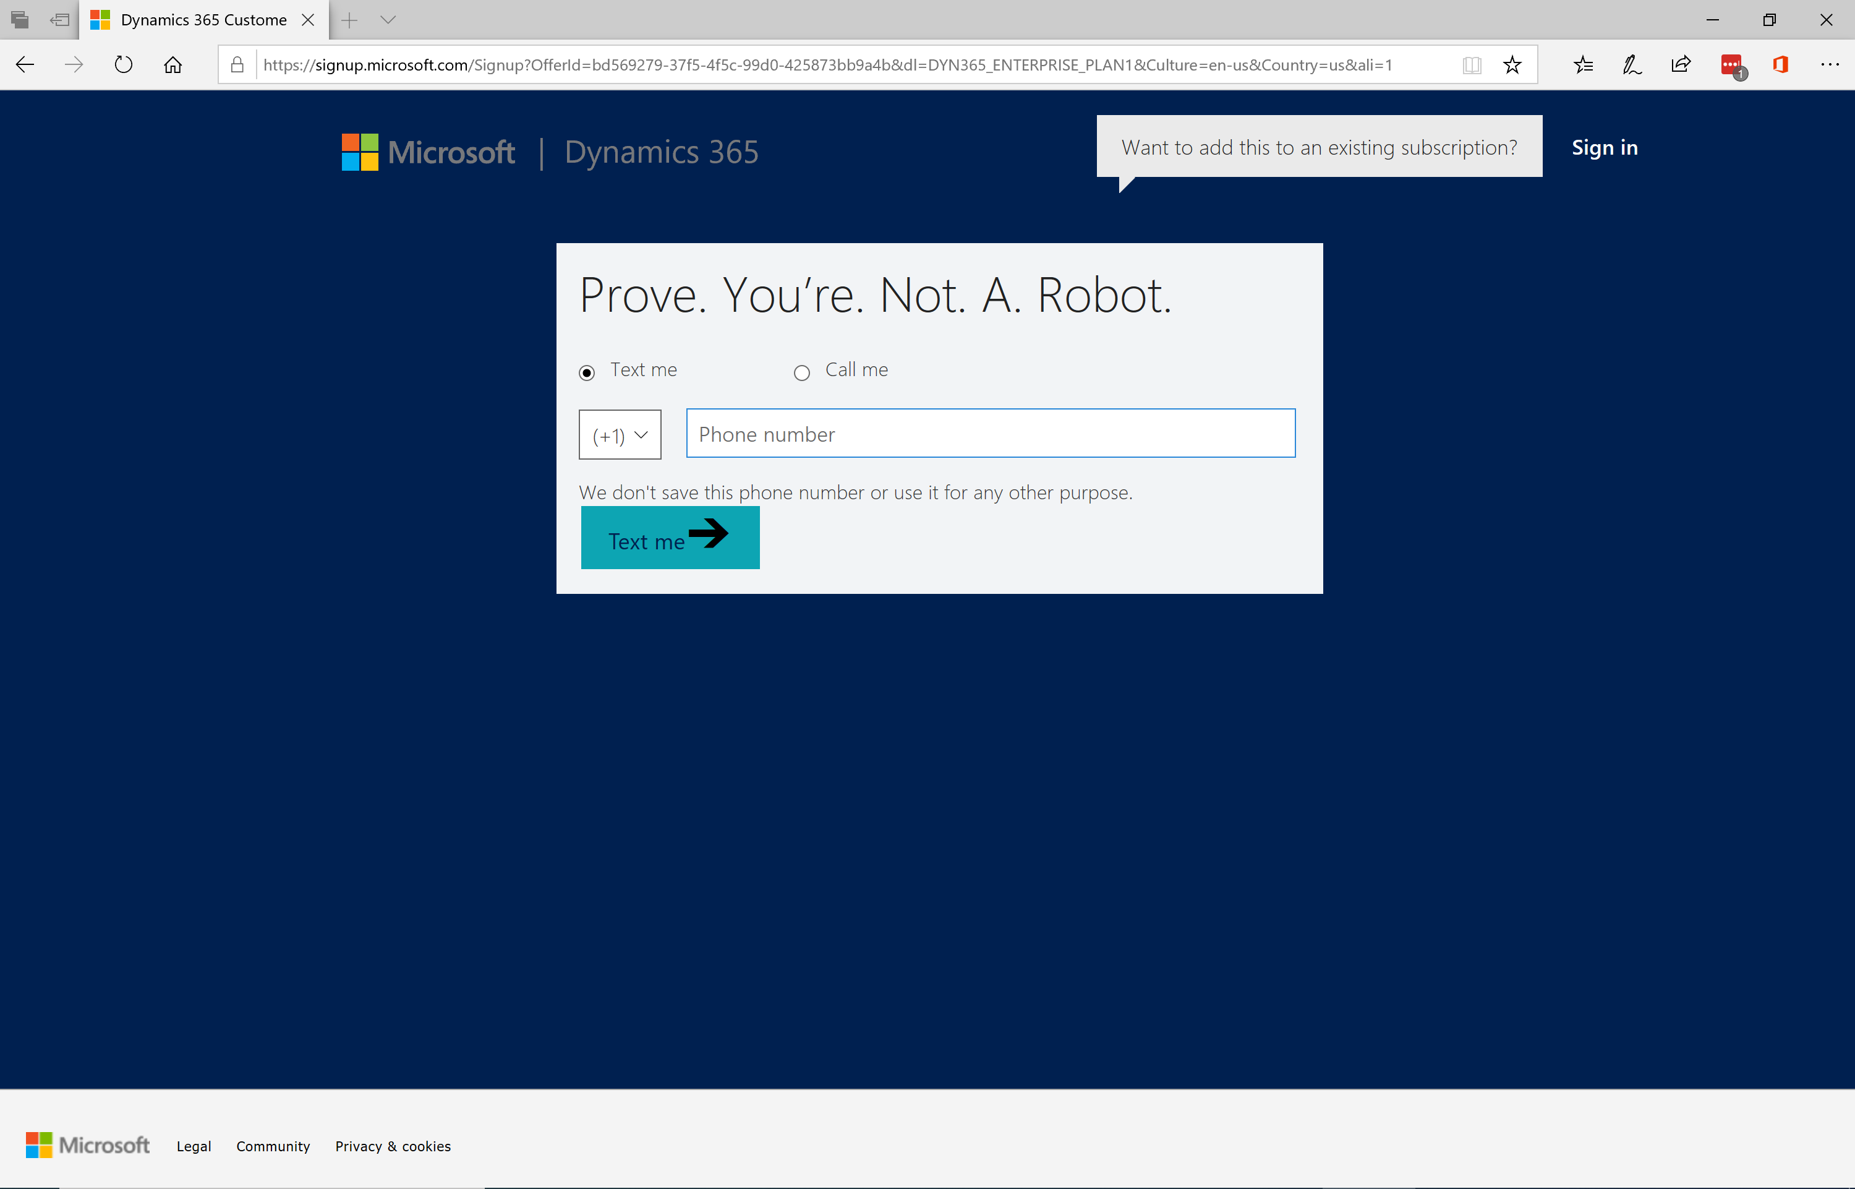

1. Save the information below (based on the user name and tenant name you chose in step 5) and then click **set up**. It may take up to 30 seconds for **set up** to appear.

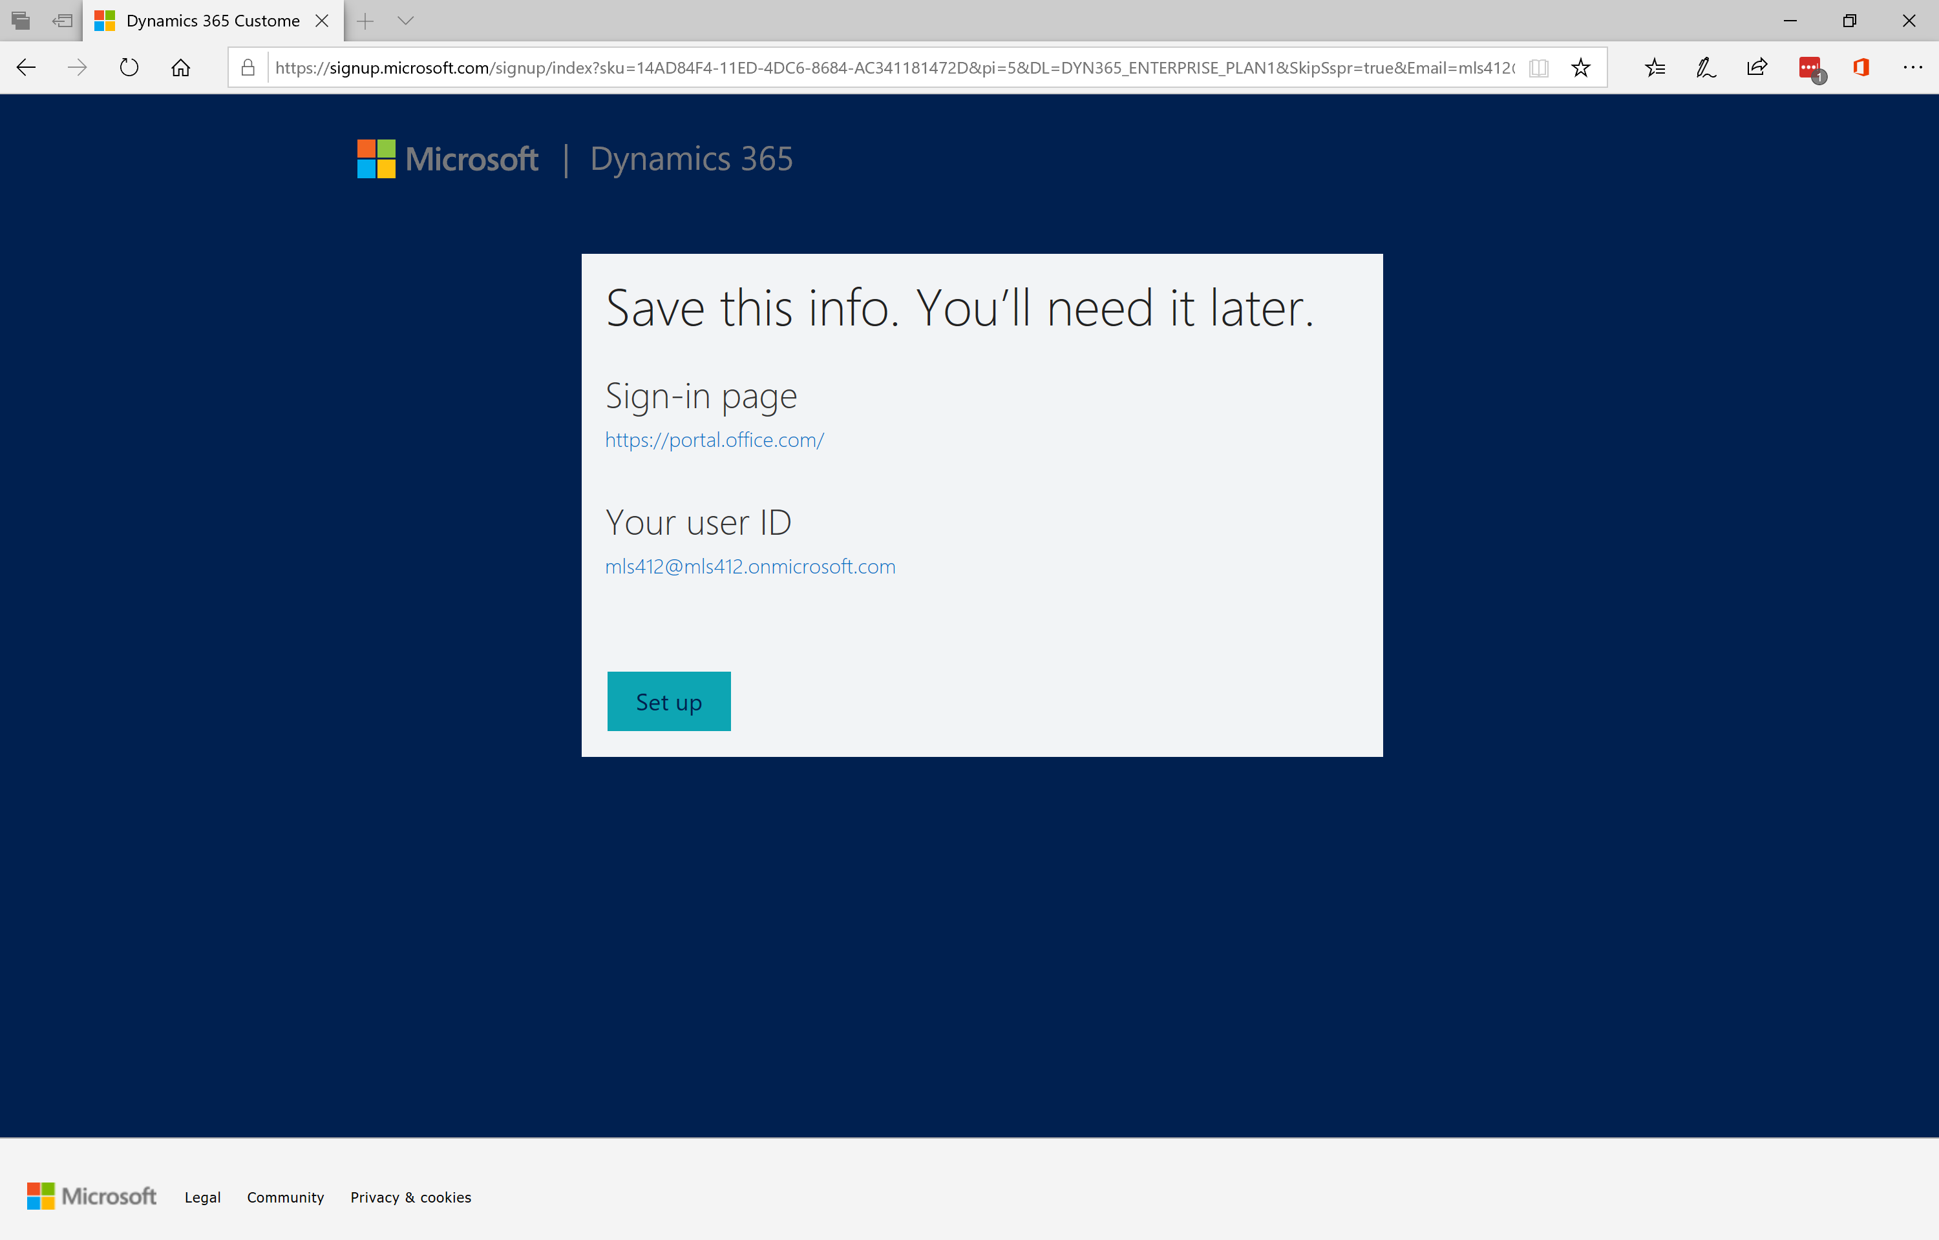

1. Log-in to your trial environment using the user name and password you chose in Step 5. The screen below may look different depending on the browser you’re using. You may also need to log-in using a private browser session to avoid conflicting with your company SSO.

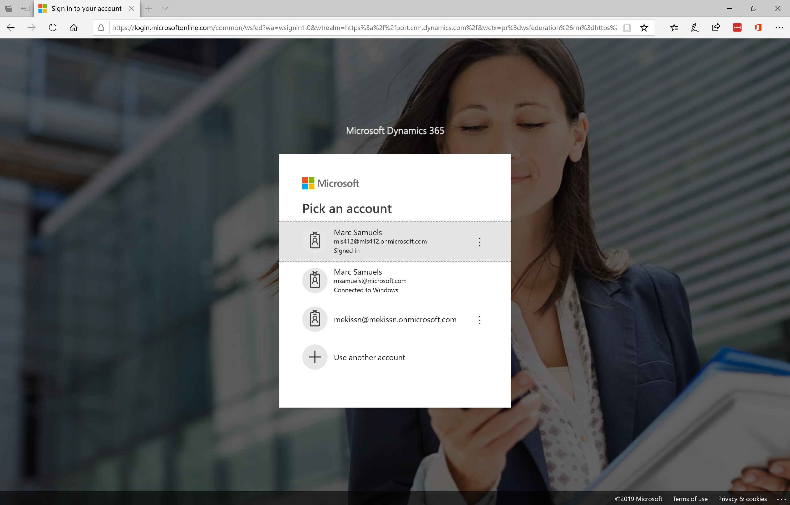

1. Choose **all of these** in the screen below (although you could provision any one and then add the other solutions after provisioning) and then click **complete setup.**

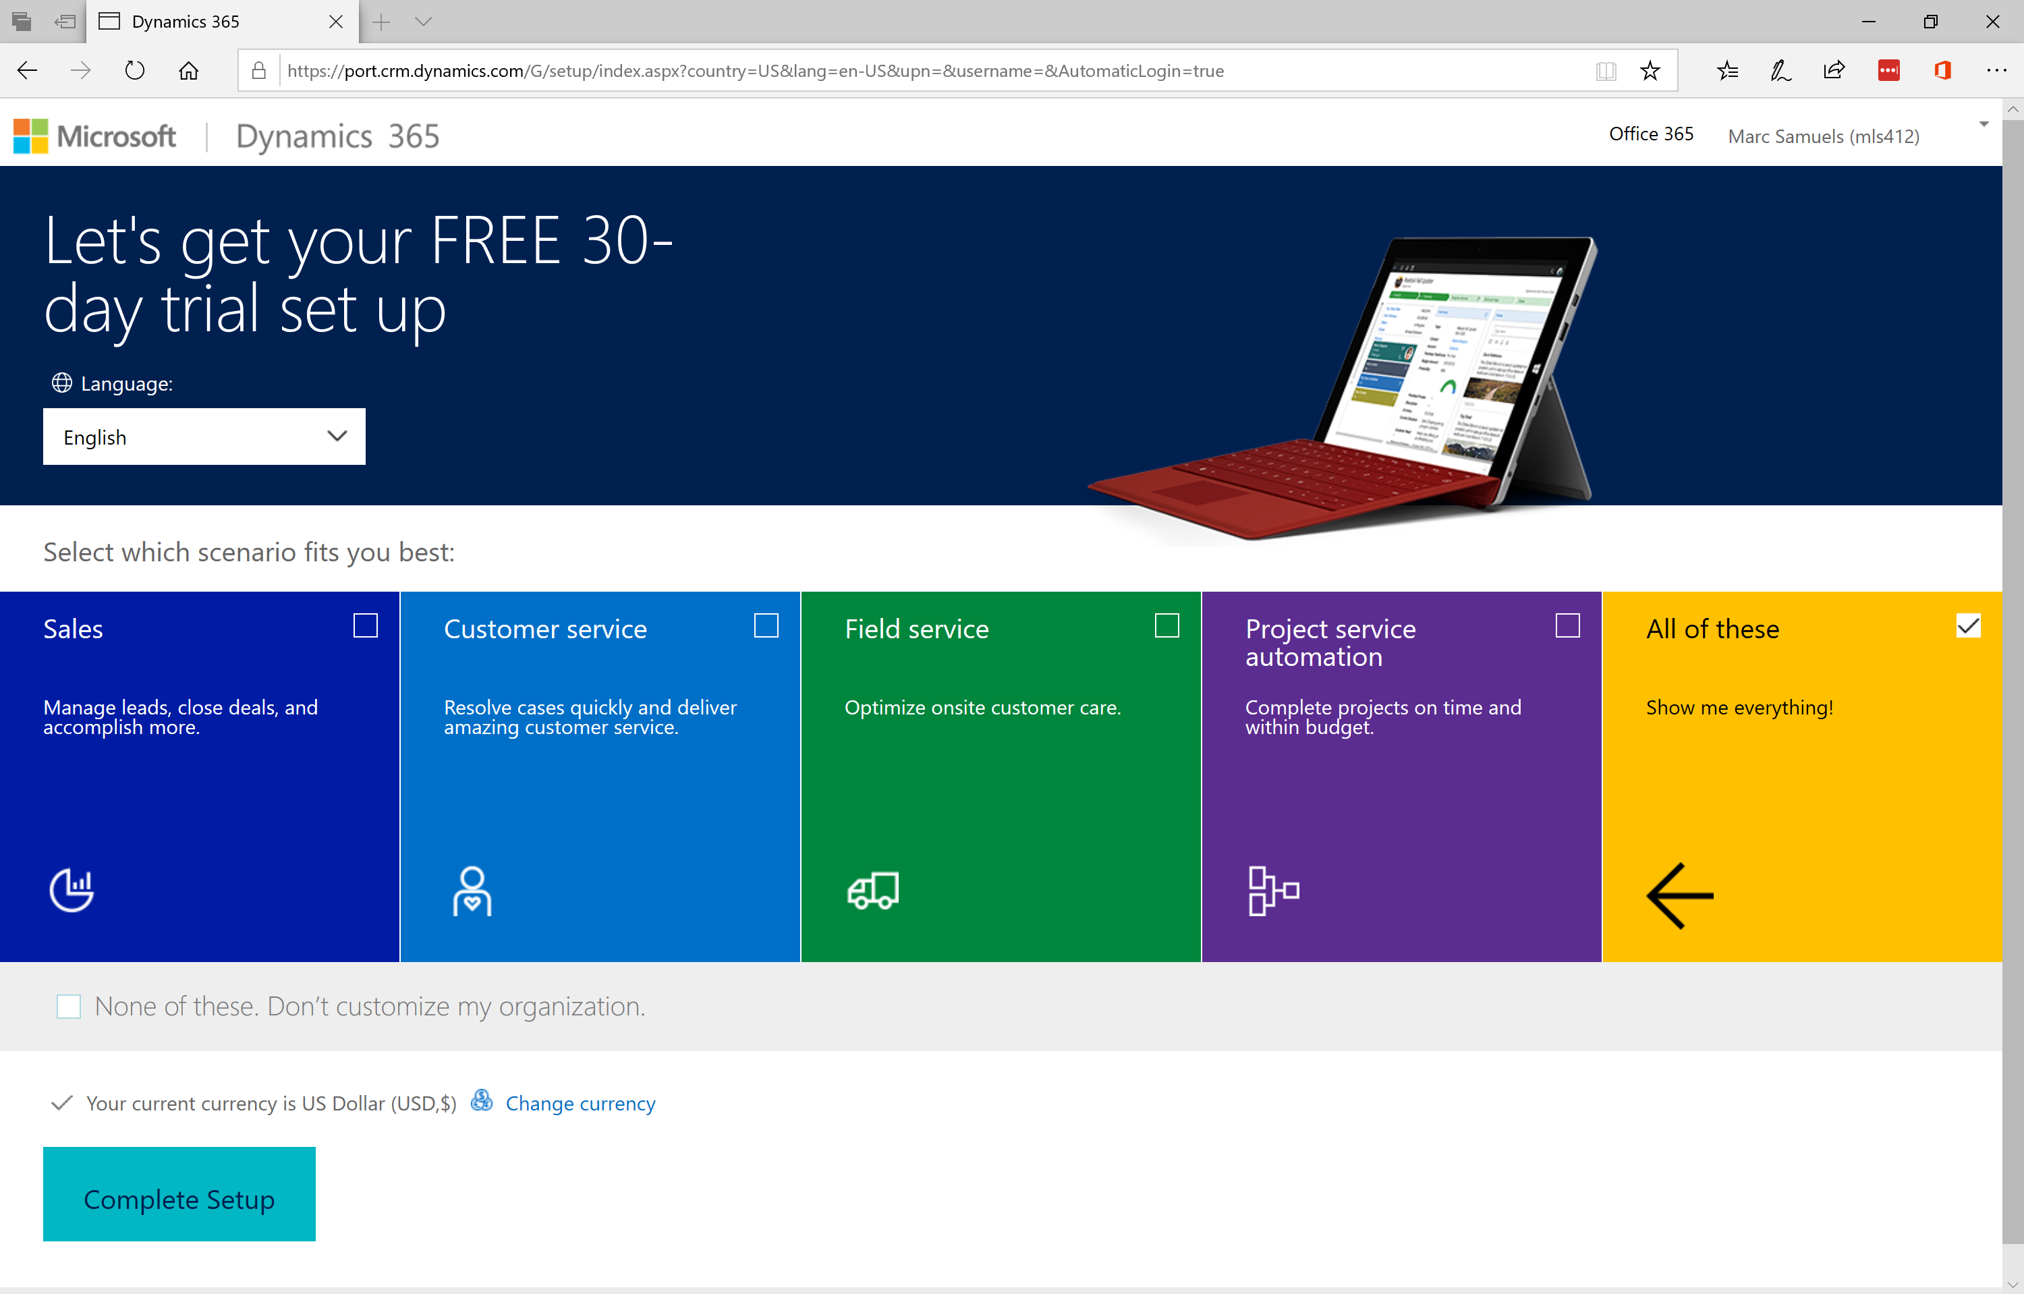

1. The process is now complete! Initial setup is typically completed within a minute (maybe 2-3 minutes) and will redirect you to the Dynamics interface as shown in the screenshot below. From there, you can access all Office 365 services, including the PowerApps interface, via the tile button in the top left hand corner. It may take 15-30 minutes for all Office 365 services to be available but then you’re good to go. Have fun!!

